1)



2)



3)



4)



5 & 6)



7)



8)



9)

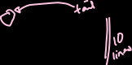

10)



11)



13)



14)



15)



16)

